Servicemeldung Nr.: / Service Report No.:

 | Maße links / Measurement left |  | ▲  Fahrtrichtung / Direction of travel |  |  | Maße rechts / Measurement right
 | Außen / Outer | Innen / Inner |  |  |  | Innen / Inner | Außen / Outer
Achse 1 / Axle 1 | Pad inkl. Belagblech  Pad incl. plate  mm | Pad inkl. Belagblech  Pad incl. plate  mm | 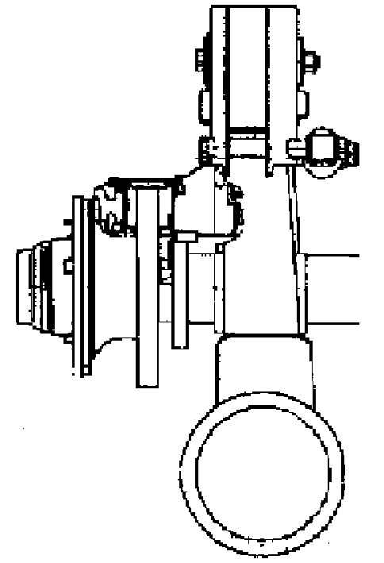 | SAF Serial-Nummer  SAF serial number | 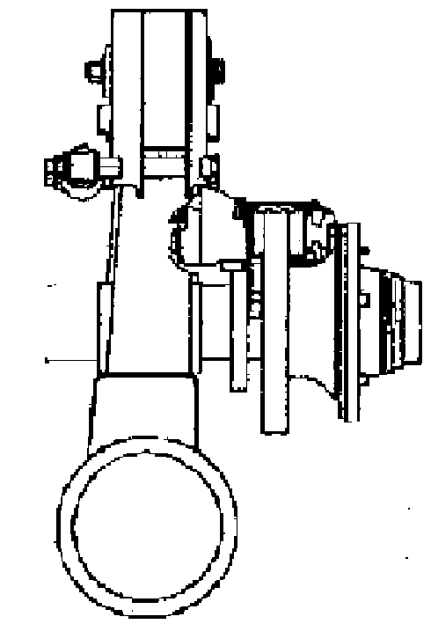 | Pad inkl. Belagblech  Pad incl. plate  mm | Pad inkl. Belagblech  Pad incl. plate  mm
Achse 1 / Axle 1 | Scheibe  Disc  mm | Scheibe  Disc  mm |  | Verschleißanzeige  Wearout indication  ja / yes nein / no |  | Scheibe  Disc  mm | Scheibe  Disc  mm
Achse 1 / Axle 1 | Gesamtstärke Bremsscheibe  Total thickness of brake disc  mm |  |  | Liftachse / Lift axle  ja / yes nein / no |  | Gesamtstärke Bremsscheibe  Total thickness of brake disc  mm
Achse 2 / Axle 2 | Pad inkl. Belagblech  Pad incl. plate  mm | Pad inkl. Belagblech  Pad incl. plate  mm |  | SAF Serial-Nummer  SAF serial number |  | Pad inkl. Belagblech  Pad incl. plate  mm | Pad inkl. Belagblech  Pad incl. plate  mm
Achse 2 / Axle 2 | Scheibe  Disc  mm | Scheibe  Disc  mm |  | Verschleißanzeige  Wearout indication  ja / yes nein / no |  | Scheibe  Disc  mm | Scheibe  Disc  mm
Achse 2 / Axle 2 | Gesamtstärke Bremsscheibe  Total thickness of brake disc  mm |  |  | Liftachse / Lift axle  ja / yes nein / no |  | Gesamtstärke Bremsscheibe  Total thickness of brake disc  mm
Achse 3 / Axle 3 | Pad inkl. Belagblech  Pad incl. plate  mm | Pad inkl. Belagblech  Pad incl. plate  mm |  | SAF Serial-Nummer  SAF serial number |  | Pad inkl. Belagblech  Pad incl. plate  mm | Pad inkl. Belagblech  Pad incl. plate  mm
Achse 3 / Axle 3 | Scheibe  Disc  mm | Scheibe  Disc  mm |  | Verschleißanzeige  Wearout indication  ja / yes nein / no |  | Scheibe  Disc  mm | Scheibe  Disc  mm
Achse 3 / Axle 3 | Gesamtstärke Bremsscheibe  Total thickness of brake disc  mm |  |  | Liftachse / Lift axle  ja / yes nein / no |  | Gesamtstärke Bremsscheibe  Total thickness of brake disc  mm

