Service Report |  | Landing Gear • Kingpins • Fifth Wheels • Slider • Trilex wheel systems • Ball races
 |  | Date |  |  |  |  |  |  |  |  | Report No. |  |  |  |  |  |  |  |  |  |  |  |  |  |  |  |  |  | Order No.
Please note: Complete the Service Report and send it to IMS Limited immediately after the occurrence of the damage. On receipt of the report, IMS Limited will send you a claim number for this report. This claim number applies to the whole handling of the work, such as e.g. enquiries, correspondence, requests for the damaged parts, documents, etc. The cost limit for the necessary repair approval is max. 3 hours labour plus material and administration.
Contact: IMS Limited • Tel.: 01509 600185 • Fax: 01509 600235 • service@imslimited.com
Address and Contact Person |  |  |  |  |  |  |  | Vehicle owner (Name, Address, Postcode, Country) |  |  |  |  |  |  |  |  |  |  |  |  |  |  |  |  |  | Garage
Tel |  |  |  |  |  |  |  | Tel |  |  |  |  |  |  |  |  |  |  |  |  |  |  |  |  |  | Tel
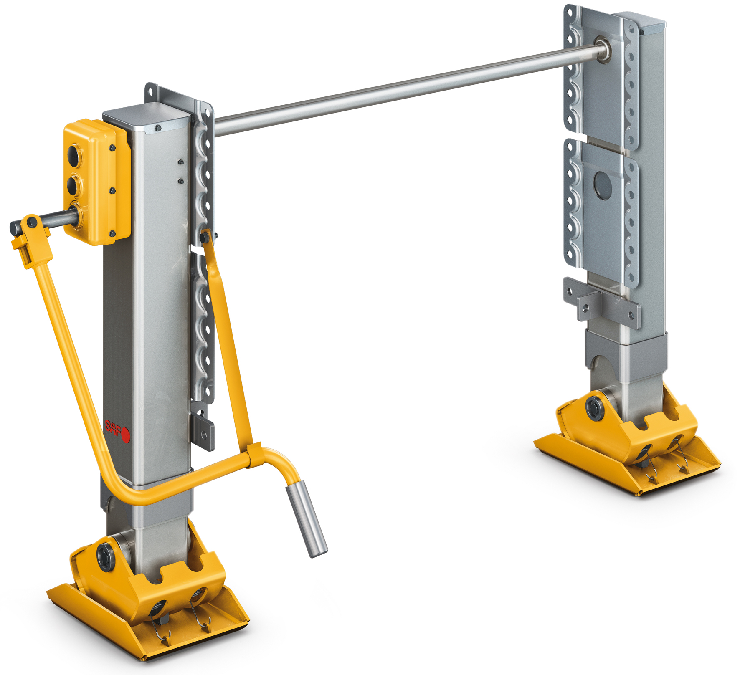 | Identification number |  |  |  |  |  |  |  |  |  |  |  |  |  |  |  |  |  |  |  |  |  |  |  | Identification number
 | spare part number damaged part |  |  |  |  |  |  |  |  |  |  |  |  |  |  |  |  |  |  |  |  |  |  |  | spare part number damaged part
 | Identification number |  |  |  |  |  |  |  |  |  |  |  |  |  |  |  |  |  |  |  | 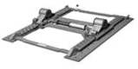 |  |  |  | Identification number
 | spare part number damaged part |  |  |  |  |  |  |  |  |  |  |  |  |  |  |  |  |  |  |  |  |  |  |  | spare part number damaged part
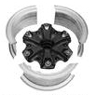 | Identification number |  |  |  |  |  |  |  |  |  |  |  |  |  |  |  |  |  |  |  | 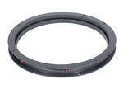 |  |  |  | Identification number
 | spare part number damaged part |  |  |  |  |  |  |  |  |  |  |  |  |  |  |  |  |  |  |  |  |  |  |  | spare part number damaged part
Tractor
Vehicle manufacturer |  |  |  |  |  |  | Type |  |  |  |  |  |  |  |  |  |  |  |  | Date of registration or installation date of spare parts
Registration No. |  |  |  |  |  |  | Chassis No. |  |  |  |  |  |  |  |  |  |  |  |  |  |  |  |  |  |  |  | Numbers of axles
Km in service |  |  |  |  |  |  | Fifth Wheel height |  |  |  |  |  |  |  |  |  |  |  |  |  |  |  |  |  |  |  | Gross vehicle weight
Trailer
Registration No. |  |  |  |  |  |  |  |  | Chassis No. |  |  |  |  |  |  |  |  |  |  |  |  |  |  |  |  |  |  | Bolster plate height
Km in service (read out from EBS/ABS) |  |  |  |  |  |  |  |  |  |  |  |  |  |  |  |  |  | Date of registration or installation date of spare part
Vehicle type |  |  |  |  |  |  |  |  |  |  |  |  |  |  |  |  |  |  |  |  |  |  |  |  |  |  |  |  |  |  |  |  |  | Other
Body type |  |  |  | Tipper |  |  |  |  |  | Box |  |  |  |  |  |  | Low loader |  |  |  |  |  |  | Platform |  |  |  |  |  |  |  | Demountable
 |  |  |  | Tank |  |  |  |  |  | Silo |  |  |  |  |  |  | Special |  |  |  |  |  |  | Concrete mixer |  |  |  |  |  |  |  | Others
Permitted axle loads |  |  |  |  |  |  |  |  |  | Tyre size |  |  |  |  |  |  |  |  |  |  |  |  |  | Single Wheel |  |  |  |  |  |  |  | Twin Wheels
Trailer standstill |  |  |  |  |  | Yes |  |  |  |  |  |  | No |  |  |  |  |  |  |  |  |  | Repair approved |  |  |  |  |  |  | Yes |  |  |  |  | No
Complaint
Stamp / signature of application

Only E-MAIL back when form is FULLY completed to
SERVICE@IMSLIMITED.COM

